Fake News Stories

Fake 1.



TECHTIMES.COM

Hawaii to Trial 30 ‘Death Pods’ After Legalizing Physician-Assisted Death

## In 2019 Hawaii became the seventh U.S. state to legalize physician-assisted death for some terminally ill patients.

**MADISON DAPCEVICH**

PUBLISHED 5 SEPTEMBER 2020

Fake 2.



TORONTOTODAY.NET

AUTOPSY: Chadwick Boseman was POISONED, homicide investigation begins

Actor Chadwick Boseman (famous for playing ‘Black Panther’ in the Marvel movies) died Friday of poisoning an early autopsy reveals. He was only 43.

**KATHY COLEMAN**

PUBLISHED 29 AUGUST 2020

Fake 3.

LATIMES.COM

Disneyland Abandoning California, Moving to Texas

The Walt Disney Company announced in September 2020 that Disneyland would be moved from Anaheim (California) to Austin (Texas).

**DAVID MIKKELSON**

PUBLISHED 8 SEPTEMBER 2020

Fake 4.

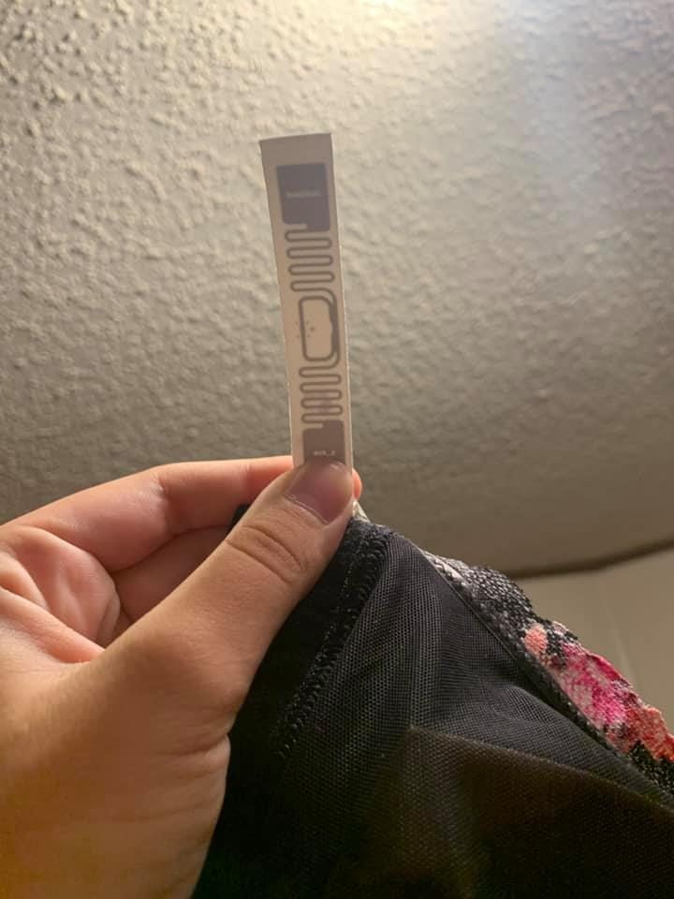

FILMDAILY.ORG

Victoria’s Secret Planting Tracking Devices in Bras

Radio-frequency identification tags used by major retailers in order to track customers.

**DAN EVON**

PUBLISHED 25 AUGUST 2020

Fake 5.



HEALTHIMPACTNEWS.COM

Putin’s Daughter Dies After Taking COVID-19 Vaccine

Russian President Vladimir Putin’s daughter died on Aug. 15, 2020 after taking a second dose of experimental COVID-19 vaccine.

**JACK LONGMAN**

PUBLISHED 17 AUGUST 2020

Fake 6.



HEALTHIMPACTNEWS.COM

Coconut Oil Helps Destroy Viruses, Including Coronaviruses

New research finds that medium chain fatty acids of coconut oil helps destroy different types of corona viruses.

**Brian Shilhavy**

PUBLISHED 09 SEPTEMBER 2020

Real News Stories

Real 1.



THECONVERSATION.COM

Police: Man Snatches Shop Tip Jar after Applying for Job

After a man ran off with the tip jar at an eastern Pennsylvania pizza shop investigators didn’t have to do a lot of legwork to track him down.

**Gerd Altmann**

PUBLISHED 4 SEPTEMBER 2020

Real 2.



WASHINGTONPOST.COM

Facebook to Ban Political Ads in Week Before Election

Posts with obvious misinformation on voting policies and the coronavirus pandemic will also be removed.

**Steve Kovach**

PUBLISHED 3 SEPTEMBER 2020

Real 3.

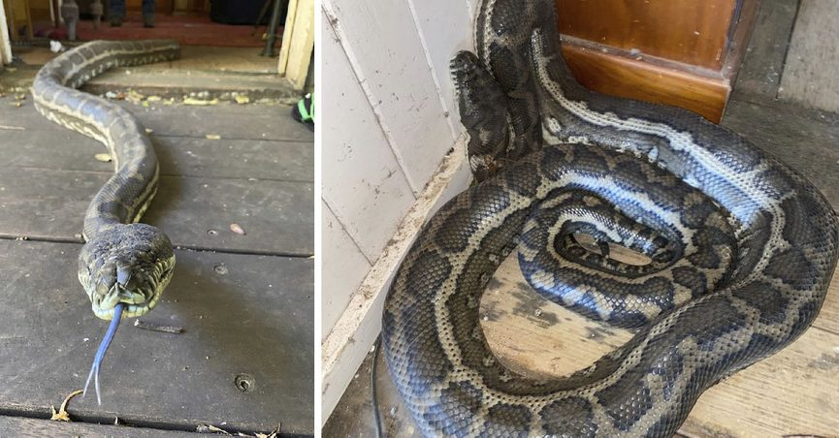

NEWYORKTIMES.COM

2 Pythons Weighing 100 Pounds Collapse Ceiling in Australia

An Australian returned home and was surprised to discover that his kitchen ceiling had collapsed under the weight of two large pythons apparently fighting over a mate.

**Steven Brown**

PUBLISHED 1 SEPTEMBER 2020

Real 4.

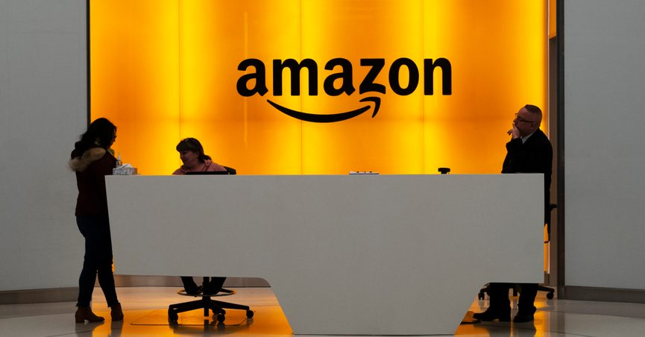

THEGUARDIAN.COM

What slowdown? Amazon seeks to hire 33,000 people

Read more at:

https://economictimes.indiatimes.com/news/international/business/what-slowdown-amazon-seeks-to-hire-33000-people/articleshow/78019602.cms?utm_source=contentofinterest&utm_medium=text&utm_campaign=cppst

It's the largest number of job openings it's had at one time, and the Seattle-based online behemoth said the hiring is not related to the jobs it typically offers ahead of the busy holiday shopping season.

**Lisa Henry**

PUBLISHED 9 SEPTEMBER 2020

Real 5.

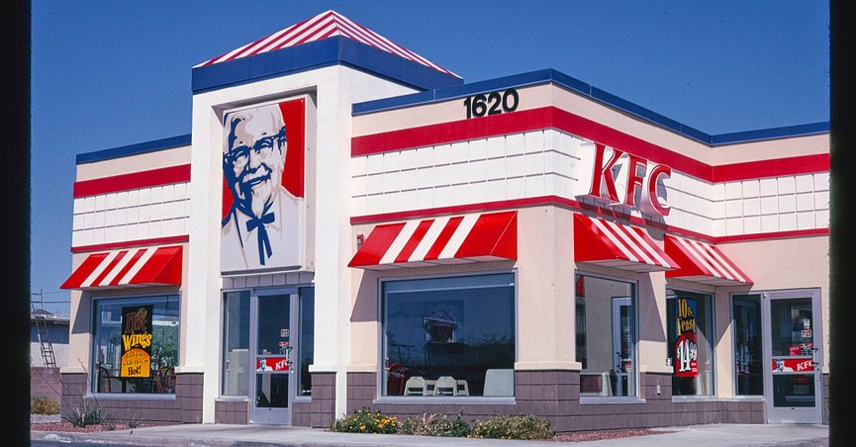

USATODAY.COM

KFC Suspends ‘It’s Finger Lickin’ Good’ Slogan Amid Pandemic

After 64 years, the slogan has been suspended as it was deemed “the most inappropriate slogan for 2020.”

**Amy Pichii**

PUBLISHED 25 AUGUST 2020

Real 6.

Real 6.

THEGUARDIAN.COM

Oregon fires force 500,000 to evacuate as blazes across American west kill 15

Unprecedented fire conditions burn more than 900,000 acres. Firefighting resources are stretched thin in three states

**Jason Wilson**

PUBLISHED 10 SEPTEMBER 2020